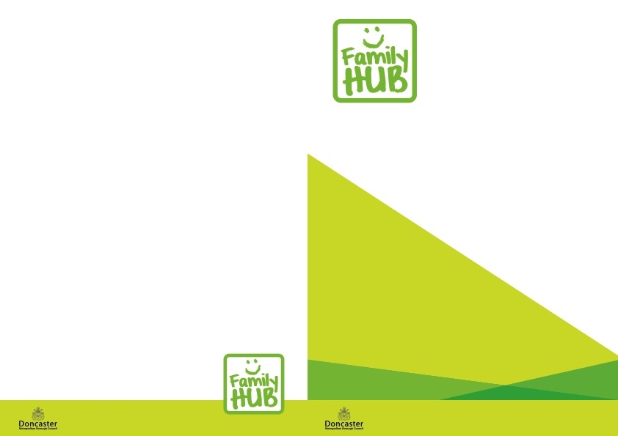

**‘Parent Zone’ Sessions**

Every Monday, Wednesday and Friday 9.30-10.00am

Any worries, concerns, or just need a friendly chat? Come and meet our Early Years Team whilst you relax at home.

Why not join us and have some fun together.

To access: please call any of our Hubs to receive the link to join:

Balby 01302 736880

Wheatley 01302 737790

Central 01302 737995

**Virtual First Friends**

Mondays 10.00-11.00am

Tuesdays 1.00-2.00pm

Fridays 10.00-11.00am (from 12th March 2021)

This is our baby group aimed at babies from Birth to moving and is supported by the Community Nursery Nurse.

To access - please call the Health Team on 01302 566776

**Doncaster-wide Virtual Family Hub**

All Doncaster Family Hubs are now offering a wide variety of free, fun and structured support services and activities for families with children via our Virtual Family Hub which can be accessed by searching online for the ‘**Doncaster Virtual Family Hub’**.

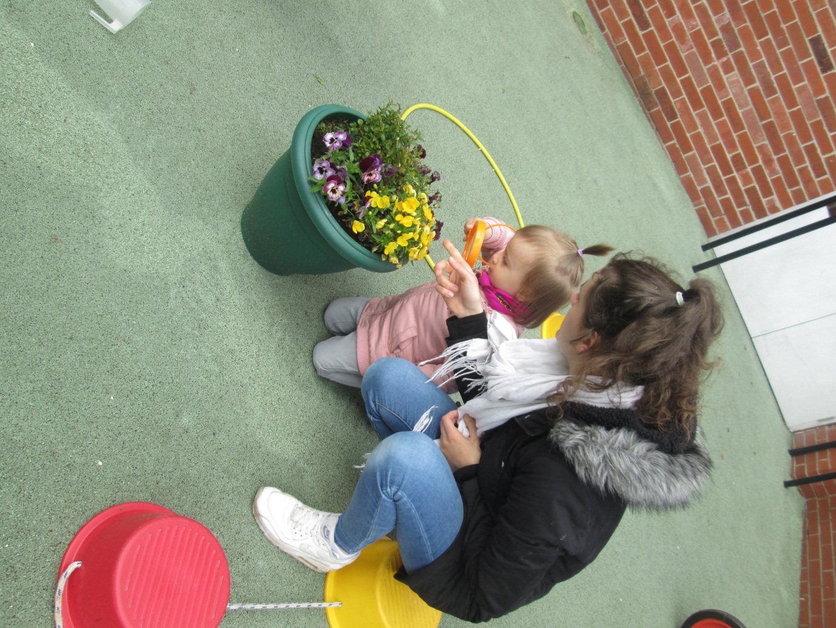

|  |  |  |  |  |  |
| --- | --- | --- | --- | --- | --- |
| **FAMILY HUB OPENING TIMES** | | | | | |
| **Central** | | **Balby** | | **Wheatley** | |
| Monday | 9.00-5.00pm | Monday | 8.30am-4.30pm | Monday | 9.00-5.00pm |
| Tuesday | 9.00-5.00pm | Tuesday | 8.30am-4.30pm | Tuesday | 9.00-5.00pm |
| Weds | 9.00-12.00pm | Weds | 8.30am-12.00pm | Weds | 9.00-12.00pm |
| Thurs | 9.00-5.00pm | Thurs | 8.30am-4.30pm | Thurs | 9.00-5.00pm |
| Friday | 9.00-4.00pm | Friday | 8.30am-4.00pm | Friday | 9.00-4.00pm |

Family Hub and Youth Action Group support a number of events and activities delivered by the Hub Team

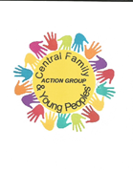

You can also find us on **Instagram** @doncasterfamilyhubs



All activities are free of charge unless stated!

**CENTRAL LOCALITY FAMILY HUB TIMETABLE**

**From 15 March 2021**

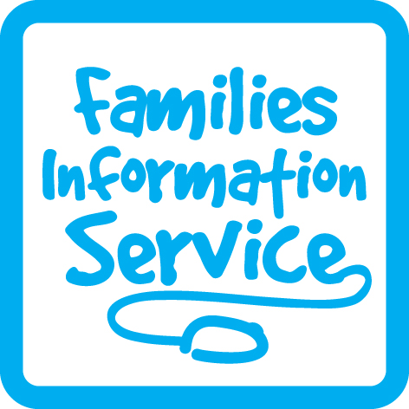



**We are on Facebook**



Balby Family Hub

1 Sandycroft Crescent, Balby

Doncaster DN4 0TY

Tel: 736880

Central Family Hub

Welcome Way

Doncaster

DN1 3LE

Tel: 737995

Wheatley Family Hub

Old School Way

Beckett Road

Wheatley, Doncaster

DN2 4AJ

Tel: 737790



**Face to Face Baby Fun Sessions within our Family Hubs:**

**An exciting new group happening within the safe environment of our Family Hubs for one parent/carer plus baby.**

**Mondays**

At Central Family Hub 1.30-2.30pm

**Tuesdays**

At Balby Family Hub 10.00 -11.00am

At Central Family Hub 1.30 -2.30pm

**Thursdays**

At Wheatley Family Hub 10.00-11.00am

Please call us to book your place

**Virtual Service Delivery**

**In the Central Area we have the following interactive groups which you can join through Microsoft Teams**:

**Please call any Central Area Family Hub to book on and we will email you the link to join.**

**Mondays**

**Virtual Sing and Shake** Monday 10.00-10.30am

For children 0-5 years

Ideas to support your child through music, movement and a range of activities which can be done in the family home encouraging early language and communication development and contrbutes to school readiness.





**Tuesdays**

**Virtual Book Chatter, Book Play**

Tuesday 10.30-11.00am

For children 0-5 years

Book Chatter, Book Play is aimed at supporting your child with Communication and Language.

We will read stories, share rhymes do have fun activities.

Resources will be delivered after booking your place.

**Thursdays**

**Virtual Messy Play** Thursday 11.00-11.30am

For children 0-5 years

Once booked on, you will receive an activity pack. Activities will include Playdough, salt dough, painting hands and feet plus much more!

**Virtual Jumping Tots** Thursday 2.00-2.30pm

For children 0-5 years

Come and join us as we have fun whilst up on our feet! With dancing, singing, games, nursery rhymes, and other exciting activities!

**Fridays**

**Virtual Nature Explorers** Friday 1.30-2.00pm

For children 0-5 years

An interactive session exploring the outdoors at home.

This session includes a range of different nature activities, including nature hunts, and leaf mark making.

**Virtual Book Chatter, Book Play** Fridays 2.00-2.30pm

For children 0-5 years

Book Chatter, Book Play is aimed at supporting your child with Communication and Language. We will read stories, share rhymes and do fun activities. Resources will be delivered after booking your place.

**Virtual Service Delivery**