

**CENTRAL AREA FAMILY HUBS**

**Easter Timetable**

**Monday 29th March to**

**Friday 9th April 2021**

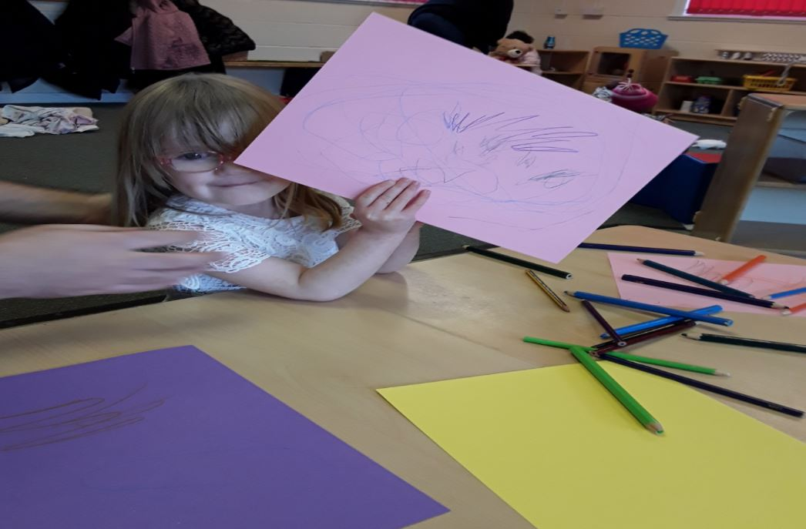

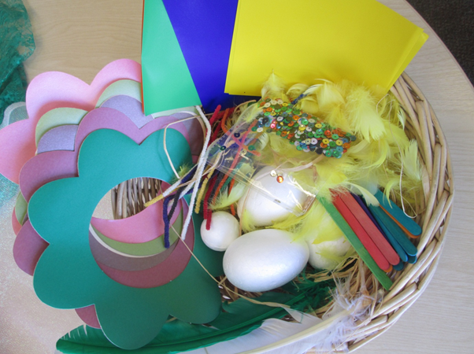

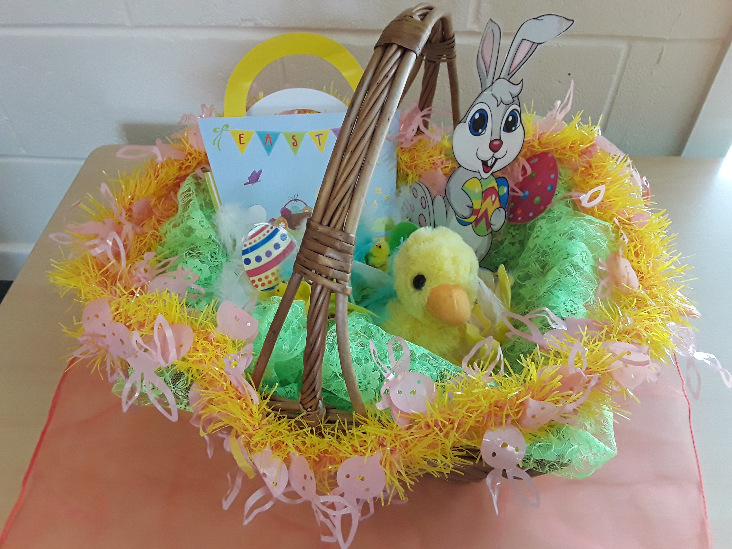

Wheatley Family Hub

Old School Way

Beckett Road

Wheatley, Doncaster

DN2 4AJ

Tel: 01302 737790

Central Family Hub

Welcome Way

Doncaster

DN1 3LE

Tel: 01302 737995

Balby Family Hub

1 Sandycroft Crescent

Balby, Doncaster

DN4 0TY

Tel: 01302 736880







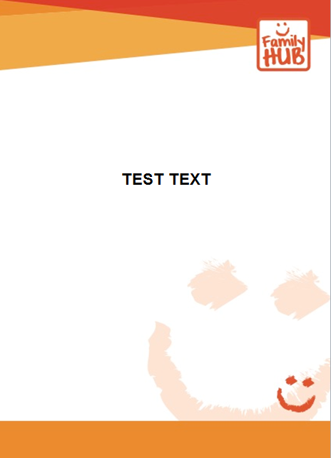

**The Great ‘Carrot Hunt!’ at Westfield Park**

**Thursday 1st April**

At Westfield Park 9.30am – 5.00pm



**Virtual** sessions on Microsoft Teams:

**Monday 29th March**

Parent Zone 9.30am-10.00am

Virtual First Friends 10.00-11.00am

**Tuesday 30th March**

Virtual Easter Book Chatter, Book Play 10.00-10.30am

Virtual First Friends 1.00-2.00pm

**Wednesday 31st March**

Parent Zone 9.30am-10.00am

**Friday 2nd April**

FAMILY HUBS CLOSED – GOOD FRIDAY

Please call any of our Central Family Hubs to book on.

Please call any of our Central Family Hubs to book on.



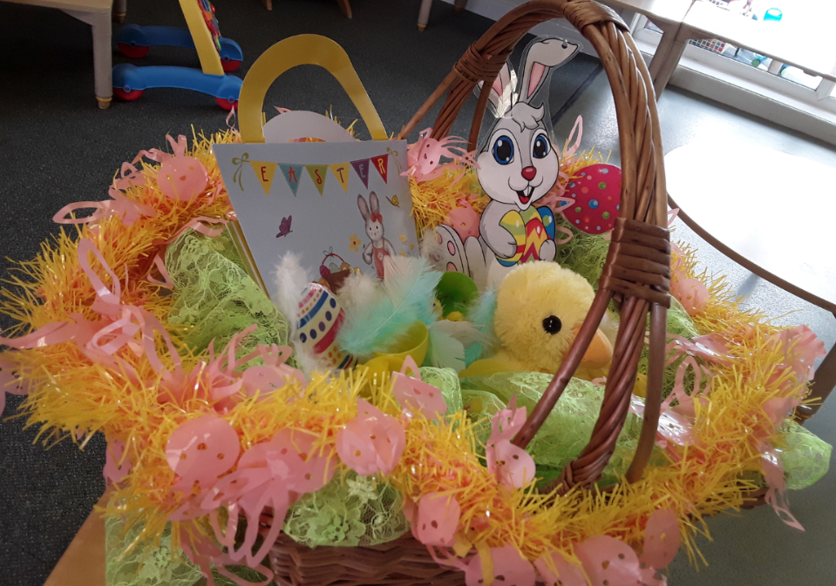

**Face to Face** Baby Fun sessions within our Hubs:

**Monday 29th March**

At Central Family Hub 1.30-2.30pm

**Tuesday 30th March**

At Balby Family Hub 10.00-11.00am

At Central Family Hub 1.30-2.30pm

**Thursday 1st April**

At Wheatley Family Hub 10.00-11.00am

**Monday 29th March- Friday 2nd April 2021**

Services delivered by: Blue- Family Hub, Red – Health Partners,

Purple – Other Partners and

Green – Family Hub and Health Partners

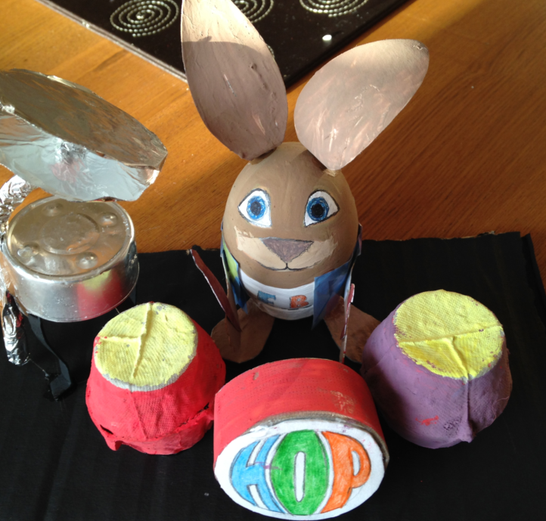





Please call any of our Central Family Hubs to book on.

**Virtual** sessions on Microsoft Teams:

**Monday 5th April**

FAMILY HUBS CLOSED – EASTER MONDAY

**Tuesday 6th April**

Virtual Spring Themed Family Sing and Shake 10.00-10.30am

Virtual First Friends 1.00-2.00pm

**Wednesday 7th April**

Parent Zone 9.30am-10.00am

**Thursday 8th April**

Virtual Family Fun 1.30-2.00pm

**Friday 9th April**

Parent Zone 9.30am-10.00am

Virtual First Friends 10.00-11.00am

**Face to Face** Baby Fun sessions within our Hubs:

**Monday 5th April**

FAMILY HUBS CLOSED – EASTER MONDAY

**Tuesday 6th April**

At Balby Family Hub 10.00-11.00am

At Central Family Hub 1.30-2.30pm

**Thursday 8th April**

At Wheatley Family Hub 10.00-11.00am

**Monday 5th to Friday 9th April 2021**

Services delivered by: Blue- Family Hub,

Red – Health Partners,

Purple – Other Partners and

Green – Family Hub and Health Partners





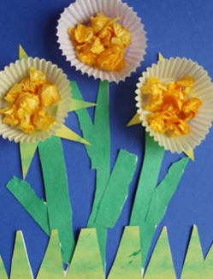

**Face to Face Baby Fun sessions**

An exciting new group happening within the safe environment of our Family Hubs for one parent/carer plus baby. To access: please call any of our Hubs to book on.

**‘Parent Zone’ Sessions**

Every Monday, Wednesday and Friday 9.30-10.00am

Any worries, concerns, or just need a friendly chat? Come and meet our Early Years Team whilst you relax at home. Why not join us and have some fun together. To access: please call any of our Hubs to receive the link to join.

**Virtual First Friends**

This is our baby group aimed at babies from birth to moving and is supported by the Community Nursery Nurse from the Health Visiting Team.

To access - please call the Health Team on 01302 566776

**Virtual Easter Book Chatter, Book Play**

**At 10.00-10.30am On Tuesday 30th March**

For children 0-11 years. Book Chatter, Book Play is aimed at supporting your child with communication and language. We will read stories, share rhymes and do fun activities around the theme of Easter.

To access: please call any of our Hubs.

**The Great ‘Carrot Hunt’ at Westfield Park!**

**On Thursday 1st April**

For children aged 0-11 years

We have heard that Easter Bunny has been hiding lots of juicy carrots at Westfield Park! All you have to do is pop to Westfield Park between 9.30am and 5.00pm on Thursday 1st April and look for the letter on each carrot which will spell out an Easter Themed Word. Once you have the word please let us know via Facebook so you can be put into our prize draw for a fantastic Easter Hamper and other great prizes! Watch out for our Facebook video on the morning of 1st April.

**Virtual Spring Themed Family Sing and Shake**

**At 10.00-10.30am on Tuesday 6th April**

For children aged 0-11 years

Join us to have some active fun as we do a range of activities involving music and movement!

**Virtual Family Fun**

**At 1.30-2.00pm on Thursday 8th April**

For children aged 0-11 years

Includes a wide range of activities around the theme of Easter and Spring.

