





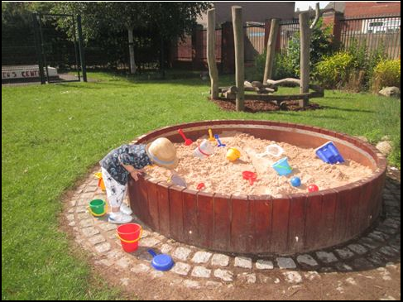

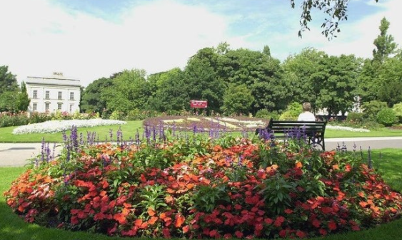

**Sing and Shake**

10.00-11.00am

At Elmfield Park

The park is between

Chequer Road (postcode DN1 2AN) and

Roman Road (postcode DN2 6AA)

Please call us to book on

**Virtual ‘Parent Zone’ Sessions**

Every Friday 9.30-10.00am

Any worries, concerns, or just need a friendly chat? Come and meet our Early Years Team whilst you relax at home.

Why not join us and have some fun together.

To access:

Please call any of our Hubs to receive the link to join.

|  |  |  |  |  |  |
| --- | --- | --- | --- | --- | --- |
| **FAMILY HUB OPENING TIMES** | | | | | |
| **Central** | | **Balby** | | **Wheatley** | |
| Monday | 9.00-5.00pm | Monday | 8.30am-4.30pm | Monday | 9.00-5.00pm |
| Tuesday | 9.00-5.00pm | Tuesday | 8.30am-4.30pm | Tuesday | 9.00-5.00pm |
| Weds | 9.00-12.00pm | Weds | 8.30am-12.00pm | Weds | 9.00-12.00pm |
| Thurs | 9.00-5.00pm | Thurs | 8.30am-4.30pm | Thurs | 9.00-5.00pm |
| Friday | 9.00-4.00pm | Friday | 8.30am-4.00pm | Friday | 9.00-4.00pm |

You can also find us on **Instagram** @doncasterfamilyhubs

Services delivered by: Blue – Family Hub, Red – Health Partners,

Purple – Other Partners and

Green – Family Hub and Health Partners

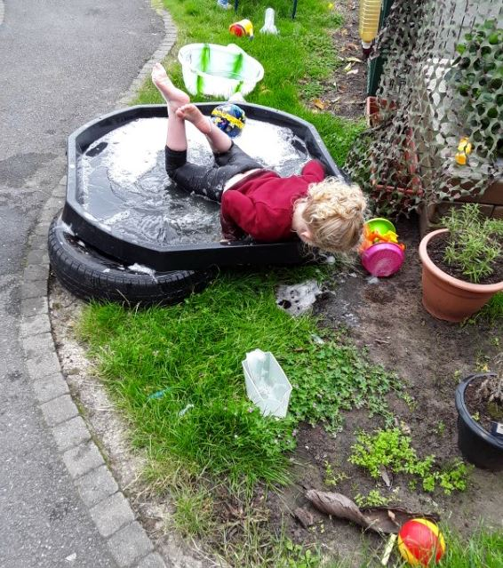

PLEASE REMEMBER **BOOKING IS ESSENTIAL**

AT THE MOMENT FOR ALL OUR SESSIONS

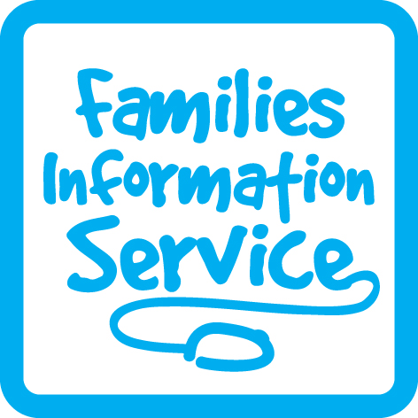

All activities are free of charge unless stated!

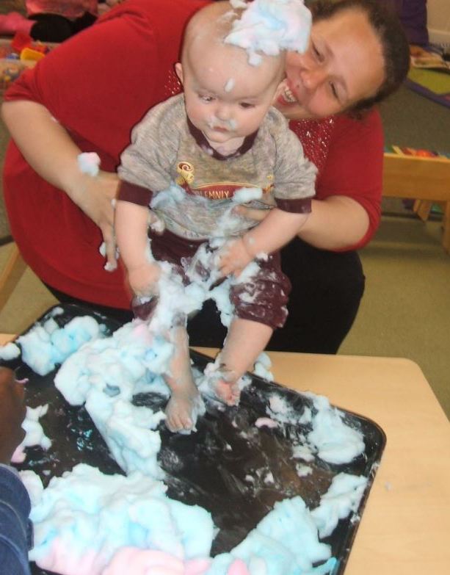



**CENTRAL LOCALITY FAMILY HUBS TIMETABLE**

**From 4 May 2021**



**We are on Facebook**



Balby Family Hub

1 Sandycroft Crescent, Balby

Doncaster DN4 0TY

Tel: 736880

Central Family Hub

Welcome Way

Doncaster

DN1 3LE

Tel: 737995

Wheatley Family Hub

Old School Way

Beckett Road

Wheatley, Doncaster

DN2 4AJ

Tel: 737790



|  |  |  |  |  |
| --- | --- | --- | --- | --- |
| **Central Family Hub** | | | | |
| Monday | Tuesday | Wednesday | Thursday | Friday |
| Midwife  9.30-10.30am  Nature Explorers  1.00-2.00pm  Stay & Play | Midwife  10.00-11.00am  Book Chatter/  Book Play  1.30-2.30pm Baby Fun | Midwife  9.30-10.30am  Buggy Walks | Midwife  10.00-11.00am  Sing and Shake ***at Elmfield Park*** | Midwife  10.00-11.00am  Mini Explorers  10.00-11.00am  Baby Massage |
| **Balby Family Hub** | | | | |
| Monday | Tuesday | Wednesday | Thursday | Friday |
| Midwife  9.30-10.30am  Stay & Play  1.00-2.00pm Nature Explorers | Midwife  10.00-11.00am  Baby Massage | Midwife  9.30-10.30am  Buggy Walks | Midwife  10.00-11.00am  Baby Fun  1.30-2.30pm  *(1.00-2.00pm*  *from 13th May)*  Mini Explorers  *(fully booked until July)* | Midwife  10.00-11.00am  Jumping Tots  1.30-2.30pm  Book Chatter/  Book Play |
| **Wheatley Family Hub** | | | | |
| Monday | Tuesday | Wednesday | Thursday | Friday |
| Midwife  9.30-10.30am  Sing & Shake | Midwife  10.30-11.30am  Book Chatter/  Book Play  1.00-2.00pm  Nature Explorers | Midwife  9.30-10.30am  Buggy Walks  9.30-10.30am  Stay & Play | Midwife  10.00-11.00am  Baby Fun  1.00-2.00pm  PHIG  (fortnightly/  term time only)  1.30-2.30pm  Jumping Tots | Midwife  10.00-11.00am  Mini Explorers  1.30-2.30pm  Baby Massage |

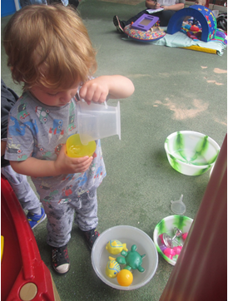

**Sessions at our Family Hubs & Local Parks**

**\*\*BOOKING IS ESSENTIAL\*\***

**Booking is essential Please ring to book on**

**Session Information:**

**Baby Fun**

Come and have fun with music, shakers, water and much more as we make new friends! An exciting group happening within the safe environment

of our hubs. For one parent plus baby.

**Mini Explorers**

For children 0-5 years

Our exciting outdoor group will involve outdoor play, exercise, gardening, messy play, sand, water, gloop and much more!

**Nature Explorers**

For children 18mths-5 years

This session includes a range of different nature activities, including nature hunts and leaf mark making.

**Buggy Walks**

For children 0-5 years

These will be alternate weeks between Town Fields, Westfield Park and Elmfield Park.

**Sing & Shake**

For children 0-5 years

Ideas to support your child through music and movement, plus activities encouraging early language development contributing to school readiness.

**Jumping Tots**

For children 0-5 years

Come and join us as we have fun on our feet with dancing, singing, games, nursery rhymes and other exciting activities!

**Book Chatter, Book Play**

For children 0-5 years

This session is aimed at supporting your child with communication and language. We will read stories, share rhymes and do fun activities.

**Stay & Play**

For children 0-5 years

This session includes lots of activities to give you and your child chance to explore, take part in new experiences and meet some new friends.