

**Virtual Stay and Play**

This virtual session will be delivered via teams and is booking only. Each session will explore something different which will include sensory play, messy play, music and instruments, physical and movement games, book & stories and song time ideas. This session will give you ideas for what you can do with your children at home.

**Rising Rockets**

Rising Rockets is a session where children are left with Early Years Development Workers to help prepare them for nursery and develop their independence. We follow a simple routine that will encourage children to choose an activity, take part in snack time and enjoy singing and story time with friends.

**Chitter Chatter**

The sessions aim to teach children and adults key life skills from a range of Forest School activities, these will enable families to engage with the natural woodland by, den building, mud play, outdoor cooking, and natural resource craft making over a duration of 12 weeks.

**Booking sessions? Please ring the Family hub as messages through Facebook can sometimes get missed.**

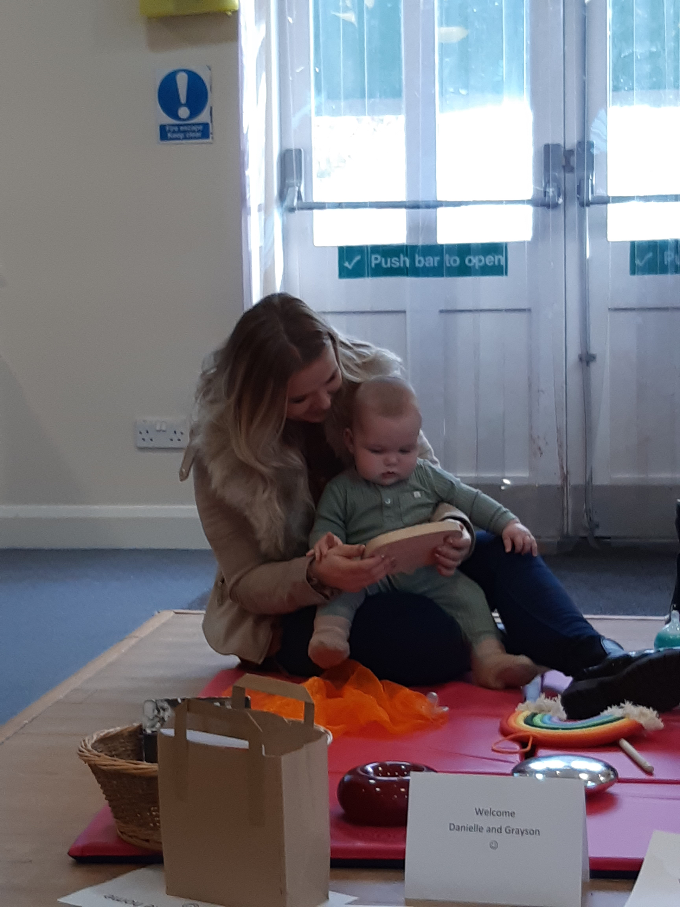

Don’t forgot to like us on Facebook for updates, you can find us at:

Bentley Family Hub

Adwick Family

Askern Family Hub

You can also find us on Instagram

@doncasterfamilyhubs

**NORTH LOCALITY FAMILY HUB TIMETABLE**

**12th April – 28th May**

**We are on Facebook**

Bentley Family Hub

The Avenue

Bentley

DN5 0NP

01302 737350

Askern Family Hub

Spa Pool Road

Askern

DN6 0HZ

01302 737099

Adwick Family Hub

Central Avenue

Woodlands

DN6 7RU

01302 737717





|  |
| --- |
| **Virtual via teams** |
| Tuesday |
| Stay & Play  (booking only)  1:30 – 2:15pm |

|  |
| --- |
| **Bentley High Street School** |
| Wednesday |
| Chitter Chatter  (Invite only)  12.00 – 2.00pm |

|  |  |  |  |  |  |  |  |  |  |  |
| --- | --- | --- | --- | --- | --- | --- | --- | --- | --- | --- |
| **Bentley Family Hub** | | | | | | | | | | |
| Monday | | | Tuesday | | Wednesday | | Thursday | | Friday | |
| Baby Fun  09:.15 – 10.15am  (Booking Only)  Infant Massage  1:00 – 2:00PM  (Invite Only)  Midwife | | | Please see other hubs for activities  Midwife | | Please see other hubs for activities  Midwife | | Sing & Shake  9:15 – 10:00am  (Booking Only)  Counselling  (by appointment)  Midwife | | Rising Rockets  9:15 – 10:45am  (Booking Only)  First Friends  1:00– 2.30pm  (Booking only)  Midwife | |
|  |  | | |  |  | |  | |  | |
| **Adwick Family Hub** | | | | | | | | | | |
| Monday | | | Tuesday | | Wednesday | | Thursday | | Friday | |
| Book Chatter Book Play  09:15 – 10:00am  (Booking Only)  Midwife | | | First Friends  1:00– 2.30pm  (Booking only)  Midwife | | Baby Fun  09:.15 –10.15am  (Booking Only)  Midwife | | Please see other hubs for activities  Midwife | | Counselling  (by appointment)  Midwife | |
|  | |  |  | | |  | |  | |  |
| **Askern Family Hub** | | | | | | | | | | |
| Monday | | | Tuesday | | Wednesday | | Thursday | | Friday | |
| Please see other hubs for activities  Midwife | | | Baby Fun  09:.15 – 10.15am  (Booking Only)  Midwife | | Sing & Shake  09:15 – 10:00am  (Booking only)  Midwife | | Bumps to Babies  10.00 – 11.00am  (Booking Only)  First Friends  1.00 – 2.30pm  (Booking only)  Midwife | | Book Chatter Book Play  1:30 – 2:15pm  (Booking Only)  Counselling  (by appointment)  Midwife | |

**Services delivered by: Red – Health Partners, Purple – Other Partners,**

**Blue – Family Hub and Green – Family Hub and Health Partners.**

**PLEASE NOTE ONLY SESSIONS RUN BY HEALTH WILL TAKE PLACE DURING THE FIRST WEEK OF SEPTEMEBER**

**North Area – Family Hub Delivery**

**From September - October 2019**

|  |  |  |  |  |  |  |  |  |  |  |
| --- | --- | --- | --- | --- | --- | --- | --- | --- | --- | --- |
| **Bentley Family Hub** | | | | | | | | | | |
| Monday | | | Tuesday | | Wednesday | | Thursday | | Friday | |
| Childminder Drop In  9:00 – 11:00am  Rising Rockets  1.15pm – 2.45pm ( invite only)  **Rising Rockets will commence week starting 9th September** | | | Breast Start  1:00 – 2:30pm | | Growing Friends  9:30 – 11:00am  Smoke Free  9:00 – 12:00pm | | Light Group 1.00 – 2.30pm | | Stay and Play  9:30 – 11.00am  **Stay and Play will commence week starting 9th September**  First Friends  1:00 – 2:30pm | |
|  |  | | |  |  | |  | |  | |
| **Adwick Family Hub** | | | | | | | | | | |
| Monday | | | Tuesday | | Wednesday | | Thursday | | Friday | |
| Growing Friends  9.30-11.00am | | | First Friends  9:30-11:00am | | Stay and Play 9.30 – 11.00am  **Stay and Play will commence week starting 9th September** | | See other Family Hubs for sessions | | Childminder Drop In 9:00 – 11:00am | |
|  | |  |  | | |  | |  | |  |
| **Askern Family Hub** | | | | | | | | | | |
| Monday | | | Tuesday | | Wednesday | | Thursday | | Friday | |
| See other Family Hubs for sessions | | | Childminder Drop In 9:00 – 11:00am | | Stay and Play 9:30 – 11:00am  **Stay and Play will commence week starting 9th September** | | Childminder Drop In  9:15 – 11:15am  First Friends  1.00–2.30pm | | Growing Friends  9:30 – 11:00am | |
| Se | | |  | |  | |  | |  | |

**Services delivered by: Red – Health Partners, Purple – Other Partners,**

**Blue – Family Hub and Green – Family Hub and Health Partners.**